Open Powershell:
winget install --id Git.Git -e --source winget

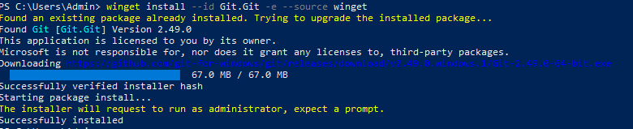
Open Gitbash:
Login/setup
- git config --global user.name "SupriyaGurindapalli"
- git config --global user.email "supriyagurindapalli5@gmail.com"
create local folder
- mkdir demo-practice
- cd demo
- git init
add and commit a file
- echo "# My demo Practice Repo" > README.md
- git add README.md //It’s a Markdown file commonly used to describe the project.
- git commit -m "Initial commit"
rename branch
- git branch -M main or git branch -M supriya
create empty repo on github
open and create new repo in github account with repo name as demo
connect local repo to github
- git remote add origin https://github.com/SupriyaGurindapalli/demo.git
push ur repo to remote(github)
- git push -u origin supriya
add more files and push
- echo "This is a notes file" > notes.txt
- git add notes.txt
- git commit -m "Added notes file"
- git push
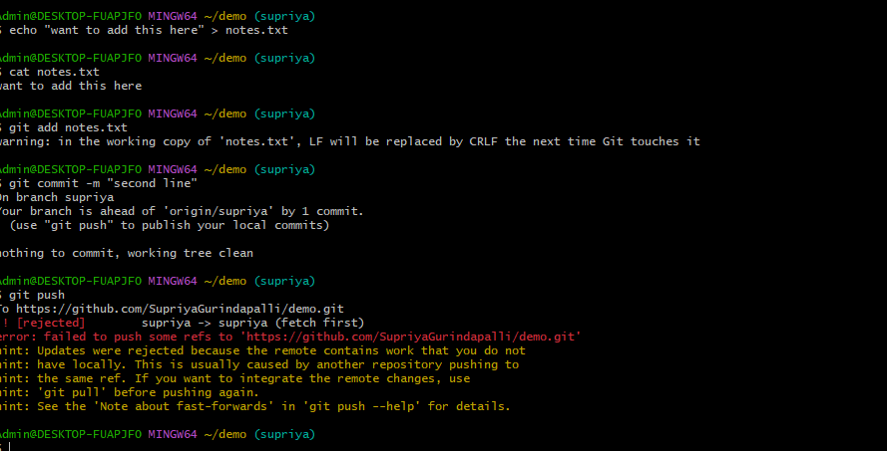

Cz I made changes in github(remote) and trying to push locally in my current branch Supriya

- git pull origin supriya –rebase // fetch the latest commits from GitHub and reapply your commit on top (clean history).
- git push origin Supriya
- git push -f origin Supriya //use this cmd instead of 16 and 17
To see history
- git log – oneline //short log
- git log //show commit history or all
what changed in last commit(show single commit details)
- git show HEAD
File-level line-by-line diffs(before commit)
- git diff (or) git diff HEAD
to append 2nd line use >>
- echo "second line" >> notes.txt
- cat notes.txt
latest changes done in github and merge remote(risk)
- git pull
latest changes done in github but not through local
- git fetch
list branches
- git branch
create a branch
- git branch child1
delete above branch
- git branch-d child1
new branch and push it to github
- git checkout -b feature/header-update // crates new branch in supriya’s latest commit. That’s y u can see notes.txt and read.md in feature branch
- echo "## New Header" > header.md
- git add header.md
- git commit -m "Added header section"
- git push -u origin feature/header-update
copy of a new branch
- git push –u origin child1 //this acts as a copy of feature/header-update so further if u make changes in header.md it gets changed in feature/header-update but not to child1
switch or change to previous branch or any
- git checkout supriya or git checkout child1
merge 2 branches
- git merge feature/header-update
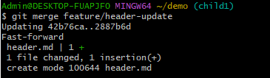

Create tag
- git tag v1.0
push tag on to github
- git push origin v1.0
delete tag
- git tag -d v1.0 //local delete
- git push origin - -delete v1.0 //remote delete
Check tag
- git tag
puts your changes aside
- git stash # Puts your changes aside
- git pull # Or git checkout another-branch
restore your changes back
- git stash pop
see all stashes
- git stash list
delete latest stash
- git stash drop
delete all stashes
- git stash clear
save stash with some msg
- git stash save “msg” // Save with a custom label (older Git)
restore but puts in stash list
- git stash apply // Apply without removing from stash
non-fast-forward push error
git push origin -u child1 //got error after pushing a file into child1
steps: git stash
git pull origin child1
git stash pop
git add .
git commit -m "Iam priya"
git push origin child1
NOTE: Working Directory – Where you edit files
Staging Area (Index) – Where you prepare files for commit
Repository (HEAD) – Where committed snapshots live
Remote handling--- show remotes
- git remote –v
link/add remote
- git remote add origin https://github.com/SupriyaGurindapalli/demo.git
rename remote
- git remote rename origin githubpractice

update remote url---should be in origin only

- git remote set-url origin https://SupriyaGurindapalli.url/demo.git
remove remote
- git remote remove origin
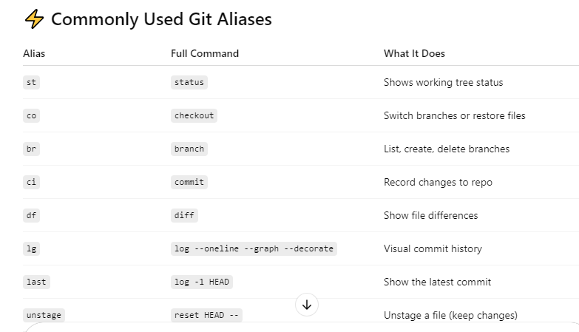
- git config --global alias.st status
- git config --global alias.co checkout
- git config --global alias.br branch
- git config --global alias.ci commit
- git config --global alias.df diff
- git config --global alias.lg "log --oneline --graph --decorate"

